CEIT 225 - Design Report Spring 2013

Name & email

Executive Summary (3 pts)
In this section you can provide a summary of approximately 200 words that allows the reader of your report to see the essential details about the project (not the report’s headings) before reviewing the whole document.
Description of the project (3 pts)
In this section describe your major goal of your project. Give information about the topic, target group and what major parts are available in your project. Please give detail description of your manual, digital content (Flash), Podcasts (or other parts that you want to include) parts of the project.
Learning Components (17 pts)
Please use your book’s Ch-7 to write this section. Especially focus on pp. 103 !
In the following section explain the components of the instruction according to Gagne’s 9 events of instruction. Give core information related with your project’s media (Paper material, Flash and Podcast). How your instructional material satisfies each learning component have to be stated here. Do not forget to associate it with your content.
- Preinstructional Activities
- Gain attention and motivating learners
What elements will you use in your instructional material to take learners’ attention? Explicitly state them and give examples (Sample text, screenshots, etc.).
- Informing learner of the objective
- Describe and promote recall of prerequisite skills and knowledge
- Content Presentation and Examples
1. Content
- Example
- Learner Participation
  - Practice- eliciting the performance
  - Providing feedback about performance correctness
In this section you have to explain how you will provide feedback for different instructional materials you will design. Provide concrete examples (i.e. Sample text, screenshots, etc.).
- Assessment
Here, describe the assessment process you will follow through, and how you will implement the assessment instruments you developed. Describe how you will give feedback about students’ performance? Explain it in details. Explicitly state them and give examples (ie. Sample text, screenshots, etc.). How will you use assessment in the instruction, practice and evaluation parts of your materials?
- Follow-through Activities
  - Memory aids for retention
  - Transfer considerations
Assessment Instruments (17 pts)
Please use your book’s Ch-9 to write this section. Especially focus on pp. 141-142 !
Do not forget to use your Instructional Objectives while designing assessment instruments.
For each assessment element do not forget to design related feedback (e.g. if a student’s response wrong, what will be your feedback?)
- Determine Mastery Levels
Consider your performance objectives that you determined in the analysis report to determine the mastery levels of your learners. Determine the mastery level for each performance objective.
- Create a matrix for type of behavior and the type of test items (multiple choice, performance, essay, etc.) for each behavior. The type of the test item should measure the intended learning outcome very well.
- Prepare assessment aspect of your project's instructional material (all four components: Entry behaviors, Pre-test, Practice test and Post-test)
This section will be associated with the Assessment component of “Learning Components” section

Instructional Approach (10 pts)
Please use your book’s Ch-8 to write this section!
Please give information about how you will apply the instructional strategy. Write which step matches with which part of the strategy and associate them to your media (paper, flash, podcast). Give as much details as possible.
Please state the following explicitly :
- How to apply principles for teaching
- How to apply tactics for teaching (e.g. will you just present plain content or will you make the learner more active?)
- How to apply enrichment tactics for teaching (e.g. how to make your instruction rich in terms of learning activities)

Content (10 pts)

Prepare all the content of the project and add it to Appendix A
Storyboard (16 pts)

Prepare the Storyboard of the Flash and Podcast, add it to Appendix B.

Visual Design Sketches of Materials (10 pts)
In this section of the report, you have to present the visual appearance of your instructional materials. Where navigational and instructional elements will be located etc. have to be shown. Prepare sketches for all major instructional strategies (e.g. intro, content, assessment, feedback, etc.). Please draw sketches of them.
Do not forget to attach it to the Appendix-C.

Expected maintenance and distribution requirements (4 pts)
In the context you have chosen, describe the major issues that you anticipate will arise for maintaining and distributing your instruction in the future. You do not have to arrange for the future use of the instruction literally, but you should envision the issues and give reasonable explanations of what you would expect to happen. The main point here is to link implementation issues to your own design decisions – for example, if you plan for you materials to be used by a community group with a low budget, you might use images and text that will reproduce well on a photocopier because you know there would not be enough money to reproduce them in color.
Describe the setting (classroom, computer lab., home, etc.) in which the lesson will take place. This will either be your description of a real setting you have visited as part of your analysis, or a realistic description of the setting suggested by the context you have chosen for the project.
Timeline and practical planning for the design (3 pts)
Include a general timeline for the completion of your design process. The timeline should show:
- The major tasks you anticipate completing as part of the design and the next step. Please indicate each tasks you finished.
- the dates by which you expect to have those tasks done,
- and the group member charged with primary responsibility for each task (even though more than one person will work on many tasks).

You can use a table like below
Date | Task / Job | Time spent | Primary Responsible Person

In this section you should also include a brief discussion of any other practical issues your group has considered in conducting the design process. You’ll get feedback on this report, but you should not wait for that feedback to carry out other stages of your project.

References and Format (3 pts)
Textbooks
Journals
Websites
Names and contact info for students, teachers and other people that you have conducted interviews

Format of the report
The main body of text for the whole document should be indented as you see it here. By indenting the text you provide readers with lines of text at an appropriate length for easy reading.
When you start a new paragraph, press the “Enter” key only one time. The style for this document creates visual space between paragraphs automatically. Paragraphs do not need to be indented. You can substitute text for the placeholder text in this template or you can simply create a new document and apply the correct styles to items in it.
Please use the same format, font, and style of this template.
Please use APA format.
{While writing reference please provide information about the resource as well as possible, for example do not write just the web address, write the title of the web page too}
Appendix-A Content of the Project
Remember, this design report will be given to developers and they will implement it, so you have to provide ALL of the content (Lesson material, quizzes, tests, etc. to developers. Provide the actual content of each instructional materials.

Appendix-B Storyboards and content flow

In this part, you need to prepare storyboard of the instruction. Although we don’t expect from you to draw all screens about your material, we want you to show general design of it and its flow. Flow of the content should be drawn with a flowchart.
Here are some storyboard examples:

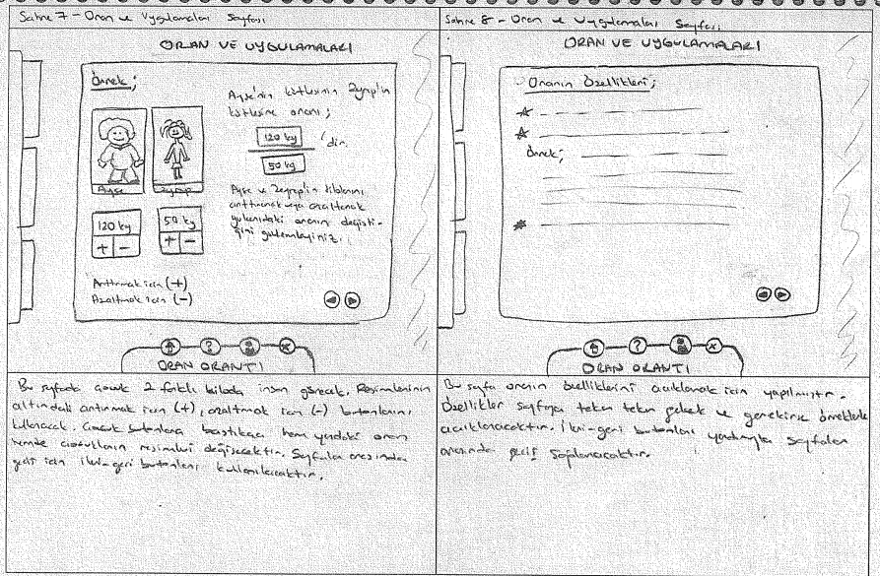
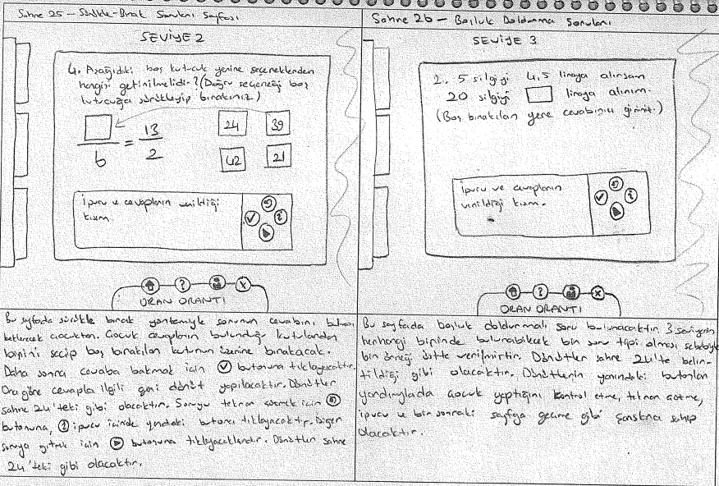
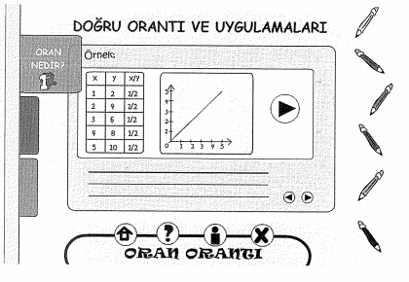
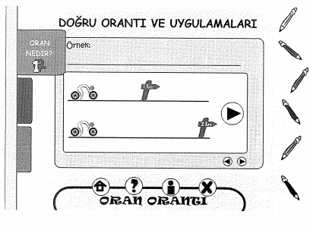

Appendix-C Visual Sketches of Materials
In this part, we want you to prepare visual sketches for all materials and major instructional strategy decisions such as Intro, Content, Assessment, Feedback, etc..

Intro

Sample Sketch
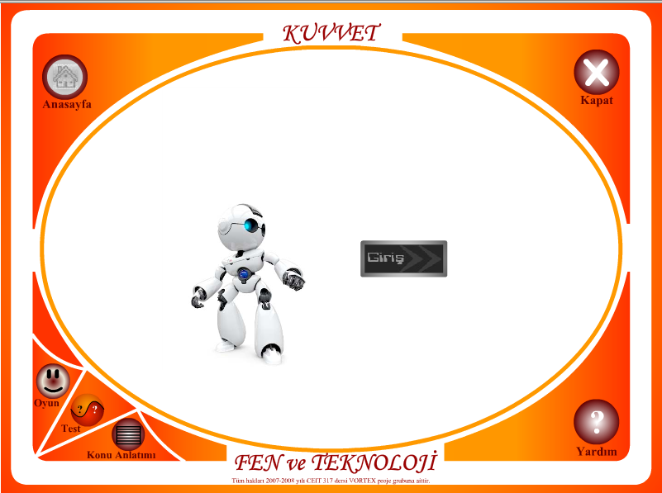

Content

Sample Sketch
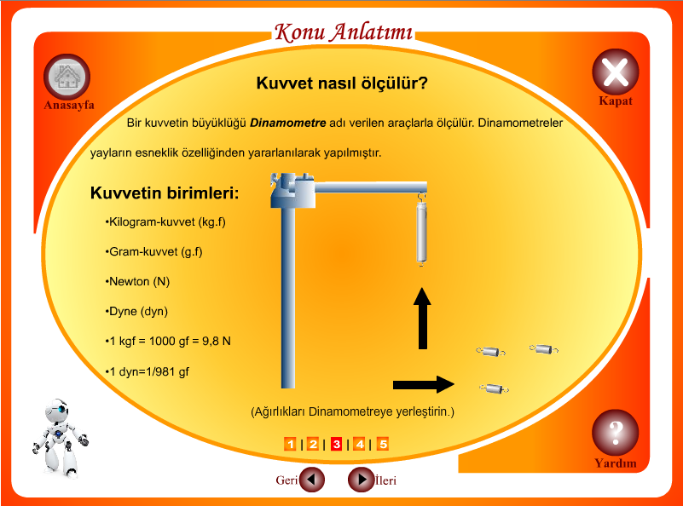

Assessment

Sample Sketch
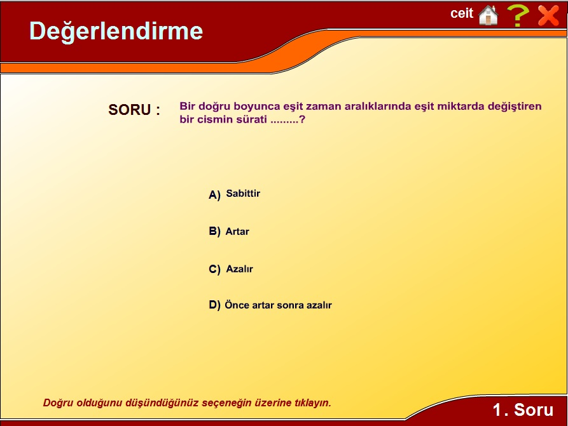

Sample sketch for paper material
