Below is a description of a graph about the average number of UK commuters travelling each day by car, bus or train between 1970 and 2030. Circle the correct option for each blank.
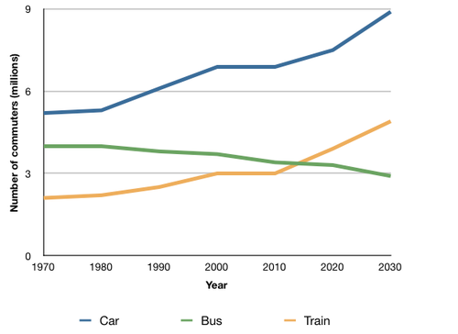
The 1. _________________ compares figures for daily travel by workers in the UK using three different forms of transport 2. _________________ a period of 60 years. The 3. _______________________ shows the number of commuters in millions whereas the 4. ______________________ represents the years.
It is clear that the car is by far the most popular means of transport for UK commuters throughout the period shown. Also, while the numbers of people who use the car and train increase 5. _______________________, the number of bus users falls 6. ______________________.
In 1970, around 5 million UK commuters travelled by car on a daily basis, while the bus and train were used by about 4 million and 2 million people respectively. Between the years 1980 and 2000, the number of those driving to work 7. ________________ and the number of commuting rail passengers reached 3 million in 2000. However, there was a small drop 8. ___________________ approximately 0.5 million in the number of bus users.
By 2030, the number of people who commute by car is expected to reach almost 9 million, and the number of train users is also predicted to rise, to nearly 5 million. By contrast, buses are predicted to become a less popular choice, 9. _______________ only 3 million daily users.

1. | a. bar graph | b. line graph | c. pie chart
2. | a. on | b. at | c. over
3. | a. horizontal axis | b. x-axis | c. vertical axis
4. | a. vertical axis | b. horizontal axis | c. y-axis
5. | a. suddenly | b. gradually | c. roughly
6. | a. steadily | b. swiftly | c. approximately
7. | a. soared | b. slumped | c. plummeted
8. | a. by | b. to | c. of
9. | a. with | b. under | c. at

Answer Key
- b. line graph
- c. over
- c. vertical axis
- b. horizontal axis
- b. gradually
- a. steadily
- a. soared
- c. of
- a. with

