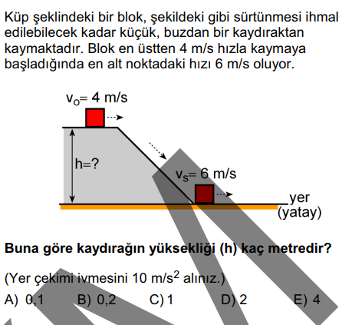  (2017 – LYS) | Çözüm:
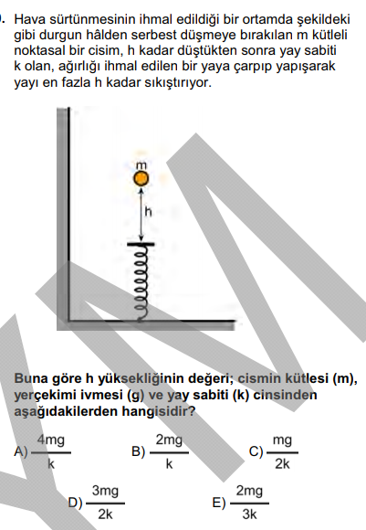  (2016 – LYS) | Çözüm:
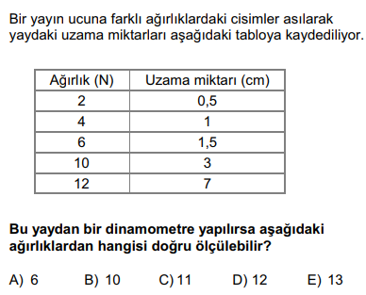  (2016 – YGS) | Çözüm:
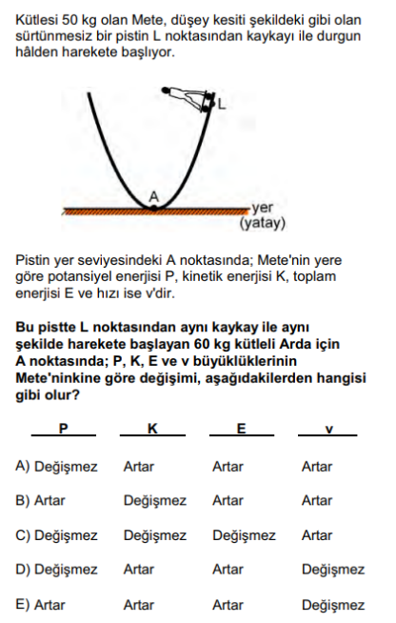  (2016 – YGS) | Çözüm:
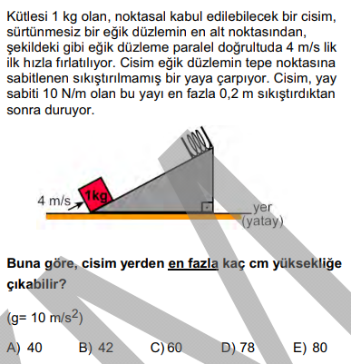  (2016 – LYS) | Çözüm:

