CEIT 225 INSTRUCTIONAL DESIGN
Play / Stop Commands
These commands can be used to play or stop a movie clip as well as main timeline

Example 1: Create a motion tween and on the actions layer, create a key frame at middle of motion tween. Then test the animation with Ctrl+Enter.

Example 2: Do same process explained in example 1 in a movie clip.

Adding a Ready Button to Stage
Follow the steps below:
- Go to window menu, find common libraries and click buttons
- Choose the button type you want to use
- Drag it to stage

Example 1: Controlling a movieclip by buttons
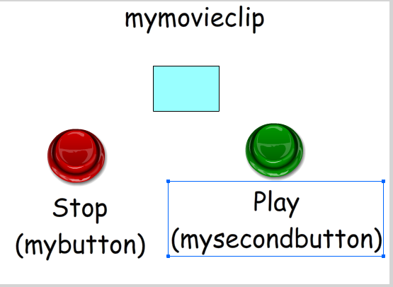
Create a movieclip on the stage and give it instance name mymovieclip. Add two classic arcade buttons to stage (a red and a green) and give them instance names mybutton for the red one and mysecondbutton for the green one.
Write the Action Scripts below on frame 1.
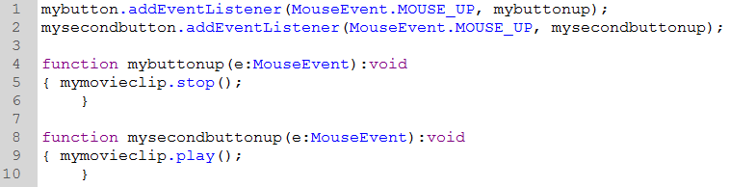

Example 2:
Create 3 layers as shown in the picture. In the “Stages” layer create 3 key frames and add a different text for each of them. In the “Buttons” layer, add two ready buttons and change names of them as “geri” and “ileri” by double-clicking each of them.
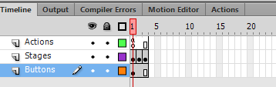
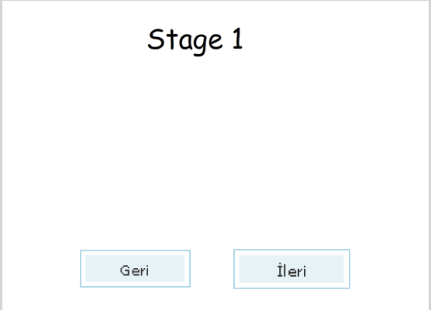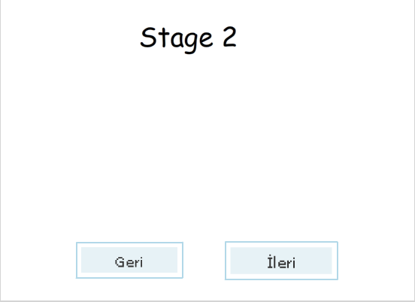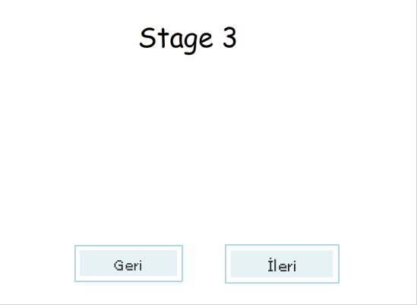
Write the Action Scripts below on the first frame of layer “Actions”
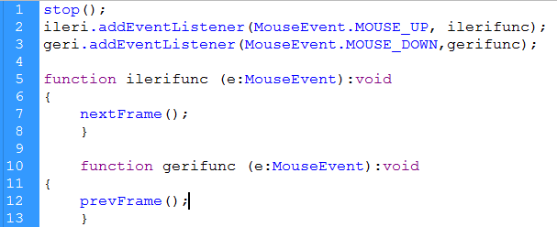

Change the codes as shown in below and try again. See the differences
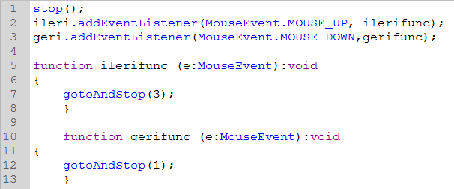
Insert a new scene from insert menu. Add a stop() script to first frame, add some objects to scene 2 and change the codes as shown in below and try again.
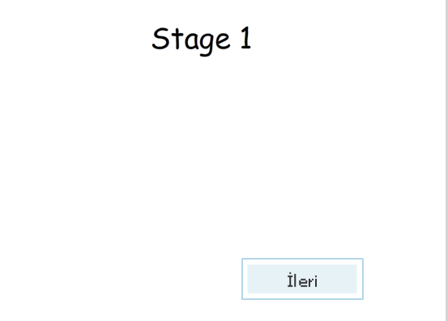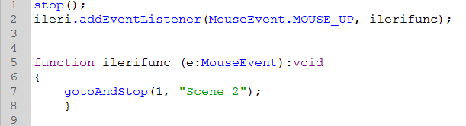
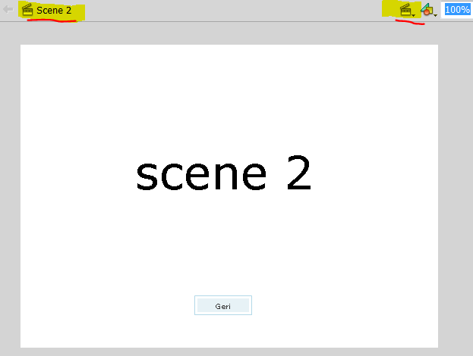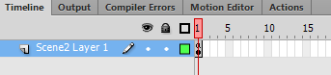
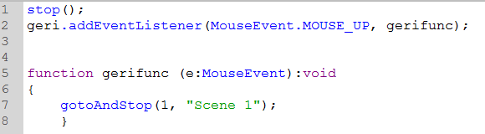
If..else
The if..else conditional statement allows you to test a condition and execute a block of code if that condition exists, or execute an alternative block of code if the condition does not exist
Usage
Var x:number=18;
If (x>20)
{ Trace(“x 20’den büyük”)
}
Else
{ Trace(“x 20’den küçük ”)
}

Example
Catch me!
Draw a circle on the stage and convert it to a Movie Clip. Then give it the instance name “ball”. Create a new layer and write action script below in the first frame of the new layer.
ball.addEventListener(MouseEvent.MOUSE_OVER, flee);

function flee(e:MouseEvent):void
{ e.target.x= Math.random()*stage.stageWidth;
e.target.y= Math.random()*stage.stageHeight;
}
Note: The method Math.Random () returns a n number where 0<=n<1 .

Text Fields
There are three choices of a text field, static, dynamic and input. A static text is just like a label. That is you can’t modify via actionscript or you can’t input anything after execute the project. If the dynamic property is selected, the text can be modified by only actionscript. A text with input property can be modified and used to keep string or number values. If you want to add borders for your text use properties menu and click “show border around text” button.
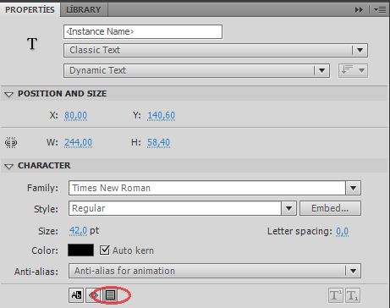

Note: Make sure that the Classic Text option is selected. Otherwise, you will not be able to see input, dynamic and static options.

Text Embedding: In order to use a text field in the project, a font should be embedded. To embed a font, certain ways can be used. Two of the ways are described below
- Right click the library and select new font
- Use Text-Font Embedding Commands from Menus
The both processes will open the font embedding window. 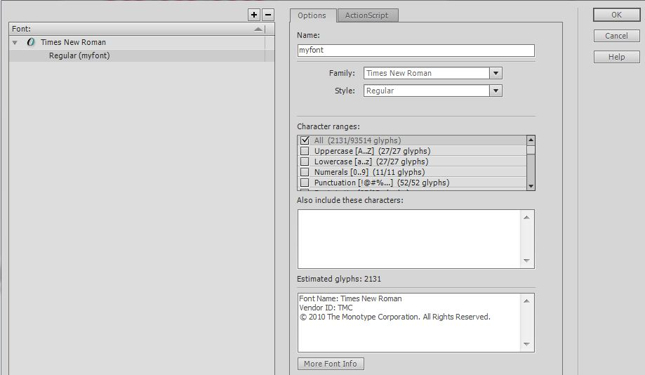
Select a font family, style and the properties that you want your font to have (Uppercase, Lowercase, Numerals, and Punctuation etc.). Give to your font a name and click plus signed button at the left-top of the window.

Example
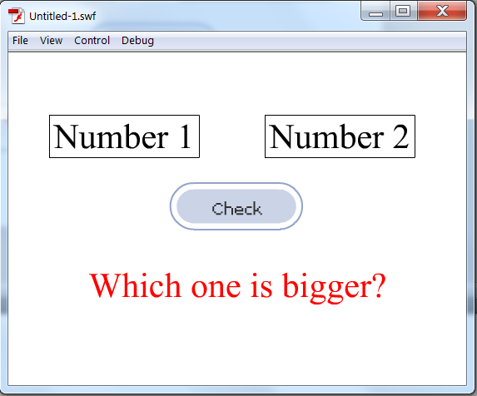
Add three text fields to stage as seen in the image. Make Number 1 and Number 2 texts as inputs and change their instance names as num1 and num2. Adjust the third text field’s mode as dynamic text and give it to instance name board. Finally add a button to stage and change its instance name as checkbutton. Then, add followed codes to the frame and press Ctrl+Enter to execute the application.

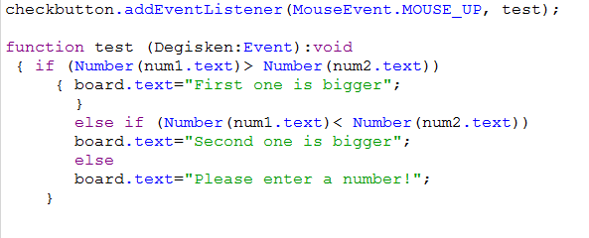
Adding Sound
In order to play a sound in Flash, you need to import it. Go to menu File, select Import and Import to Library. Select the frame that you want your sound to start and then go properties. In the sound tab, select your sound. Analyze the options in the sections Effect and Sync.
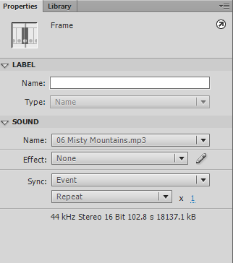
Note: The sound you added to frame lasts till the last frame so if you want your sound lasts more you need to add blank frames by F5

