ENG211 Interpreting graphs
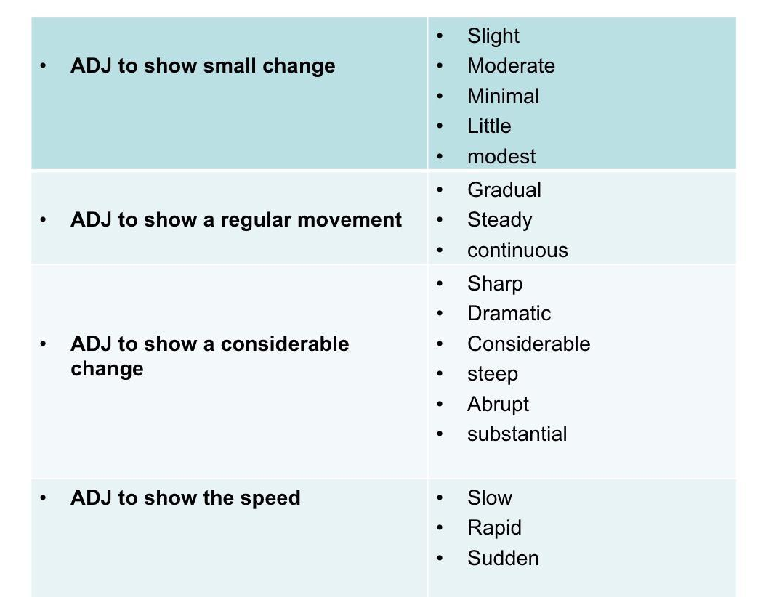
Language on pp.51-53 + table below (different degrees of change)

Analyze the graphs and fill in the blanks.

Now (1) _______________________________you a line graph which I took from an article titled Turkey GDP. The graph shows monthly exports of Turkey in 2014. (2) ______________ ________________________ shows the months while (3) _____________________________ ___________________________ shows the exports in million dollars. When we look at the graph as a whole, we see that exports in Turkey (4) ____________________________ between January and March, and they (5) ____________________ 30 million dollars in March. Monthly exports (6) _____________________ until September, and then (7) _____________________ at 10 million dollars until the end of the year.
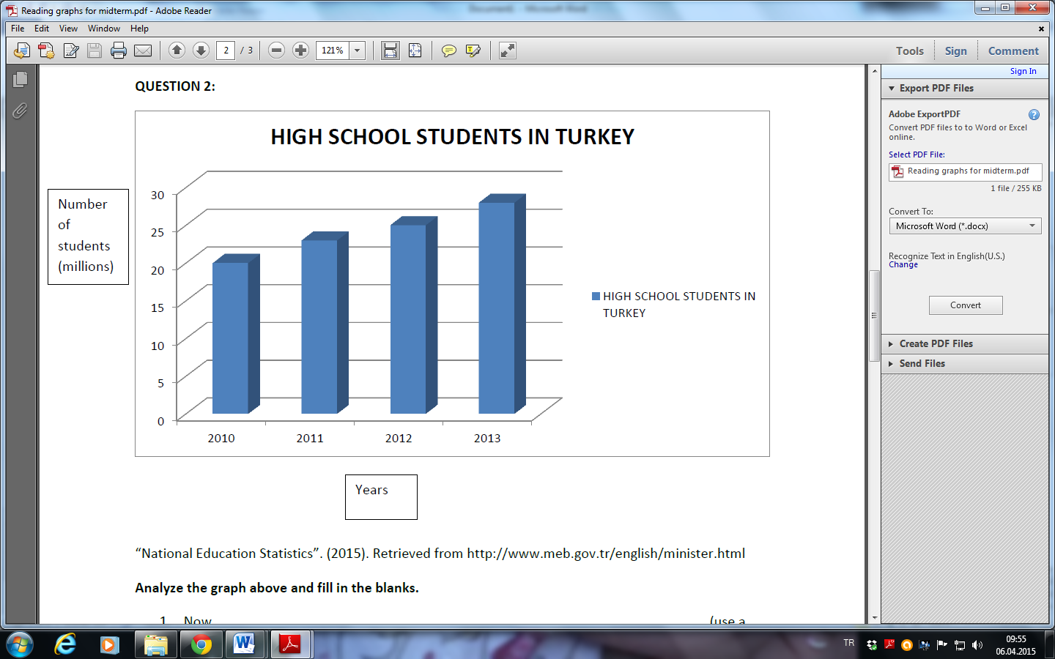

Now, let’s (1) ________________________at a bar graph which I borrowed from National Education Statistics. It shows the number of high school students in Turkey (2) ______________________________ and 2013. (3) _________________________ shows the number of students in millions while (4) _____________________________ shows the years. Clearly, we can see that there is (5) __________________________ in the number of students between 2010 and 2013 since the numbers increased from 17 million to (6) _____________________________million.

Now, I would like to draw your attention to (1) _________________ which shows the age structure of Turkish population. I (2) ______________________ the chart from the website of TUIK. As we can see in the pie chart, the largest segment of the population shows the people between the ages of (3) ________________ . Those under 14 make up (4) ____________________ of the population, and (5) ________________________ are only a small percentage of the population.

ANSWER KEY
Graph 1:
Now (1) let me show you a line graph which I took from an article titled Turkey GDP. The graph shows monthly exports of Turkey in 2014. (2) the horizontal axis shows the months while (3) the vertical axis shows the exports in million dollars. When we look at the graph as a whole, we see that exports in Turkey (4) increased significantly/ increased considerably/ increased dramatically between January and March, and the (5) peaked at 30 million dollars in March. Monthly exports (6) fluctuated until September, and then (7) leveled out/ remained steady/ remained stable/ stayed constant/ maintained the same level/ held constant at 10 million dollars until the end of the year.

Graph 2:
Now, let’s (1) have a look at a bar graph which I borrowed from National Education Statistics. It shows the number of high school students in Turkey (2) between 2010 and 2013 . (3) The vertical axis shows the number of students in millions while (4) the horizontal axis shows the years. Clearly, we can see that there is (5) a gradual increase in the number of students between 2010 and 2013 since the numbers increased (6) from 17 million to more than 25 million.

Graph 3:
Now, I would like to draw your attention to (1) a pie chart which shows the age structure of Turkish population. I (2) borrowed the chart from the website of TUIK. As we can see in the pie chart, the largest segment of the population shows the people between the ages of (3) 15 and 64. Those under 14 make up (4) 30 percent of the population, and (5) those over 65 are only a small percentage of the population.

