THE VISUAL REPRESENTATION – INTERPRETING GRAPHS

horizontal line line graph reached a peak vertical axis
dipped rose levelled off slight decrease decreased
greater soared horizontal axis fluctuated gradual increase vertical line peaked steadily

a. Let me show you a/an 1. ___________________________________which was published in 2015 by the NHS. The line graph shows us the average consumption of fresh produce. The 2. _____________________________________________ represents the years and the
3. _______________________represents the consumption of fresh produce in grams. Consumption of vegetables and fruits 4. _____________________ steadily from 1970 to 1990. and then 5. ____________________________between 1990 and 1995. There was a/an 6. __________________________________ after 1995. The consumption
7. _________________________ at 475 gr per person in 2004. Since then consumption has 8. _____________________. Between 2020 and 2030, it is projected to decline 9. _____________________ We can conclude that in future, consumption of fresh vegetables and fruit will not be popular and perhaps meat consumption will be __________________.

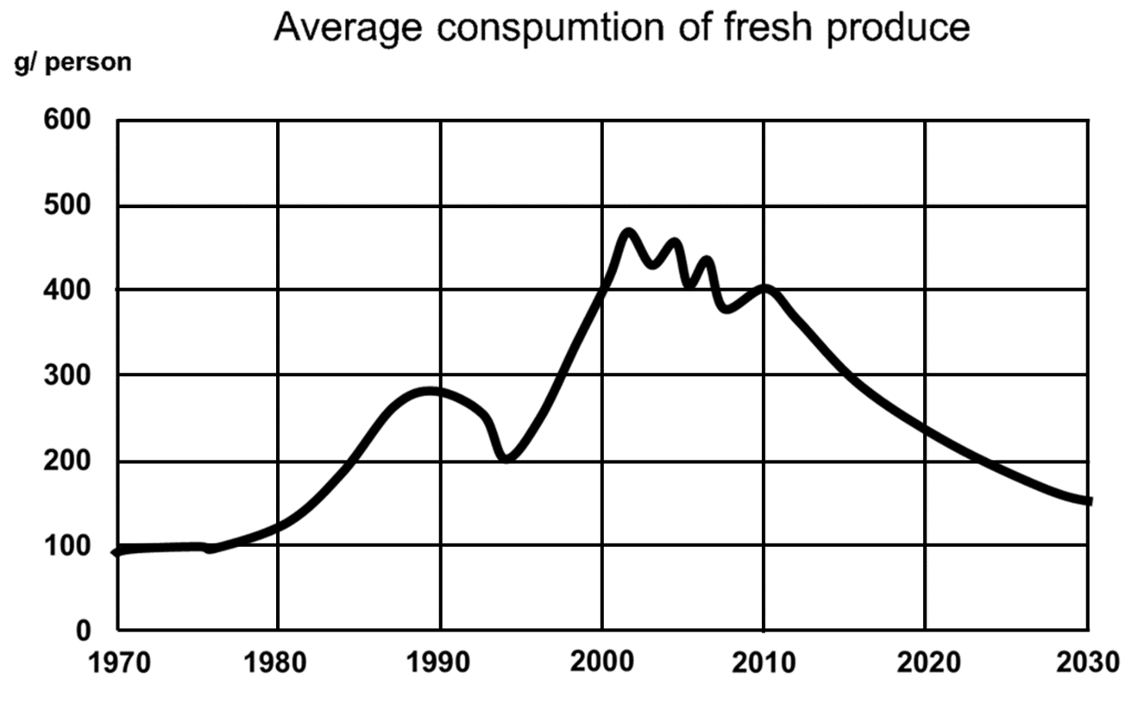
Average consumption of fresh produce

b. I would like to share with you a/an 1. ______________ about the malnutrition percentages among the elderly. I borrowed this graph from an article published by the Ministry of Health in 2016. While 2. ______________ shows the percentage of the malnourished elderly, 3. __________ ____________________represents the years. The percentage of malnourished elderly in the EU 4. __________________________________ between 1970 and 1978. Over the following seven years, it
5. __________________________________, until 1989, when it
6. __________________________________at 16%. After 1989 the rate of malnutrition was 7. _________________________________ for a decade. Since 2000, there has been a/an 8. __________________________________ fall. Over the next 10 years, it is projected to 9. __________________________________Therefore, we can conclude that malnutrition related illnesses might be on the rise in future among the elderly.
1 a. organigram b. flow chart c. line graph d. bar graph
2.. a. the vertical line b. the vertical axis c. the horizontal line d. the horizontal axis
3. a. the vertical line b. the vertical axis c. the horizontal line d. the horizontal axis
4. a. slumped b. soared c. fell slightly d. levelled off
5. a. plummeted b. fluctuated c. soared d. increased slightly
6. a. peaked b. climbed c. levelled d. slumped
7. a. decreased b. steady c. fluctuated d. levelled out
8. a. moderate b. substantial c. slight d. modest
9. a. increase gradually b. fluctuate c. level out d. plunge

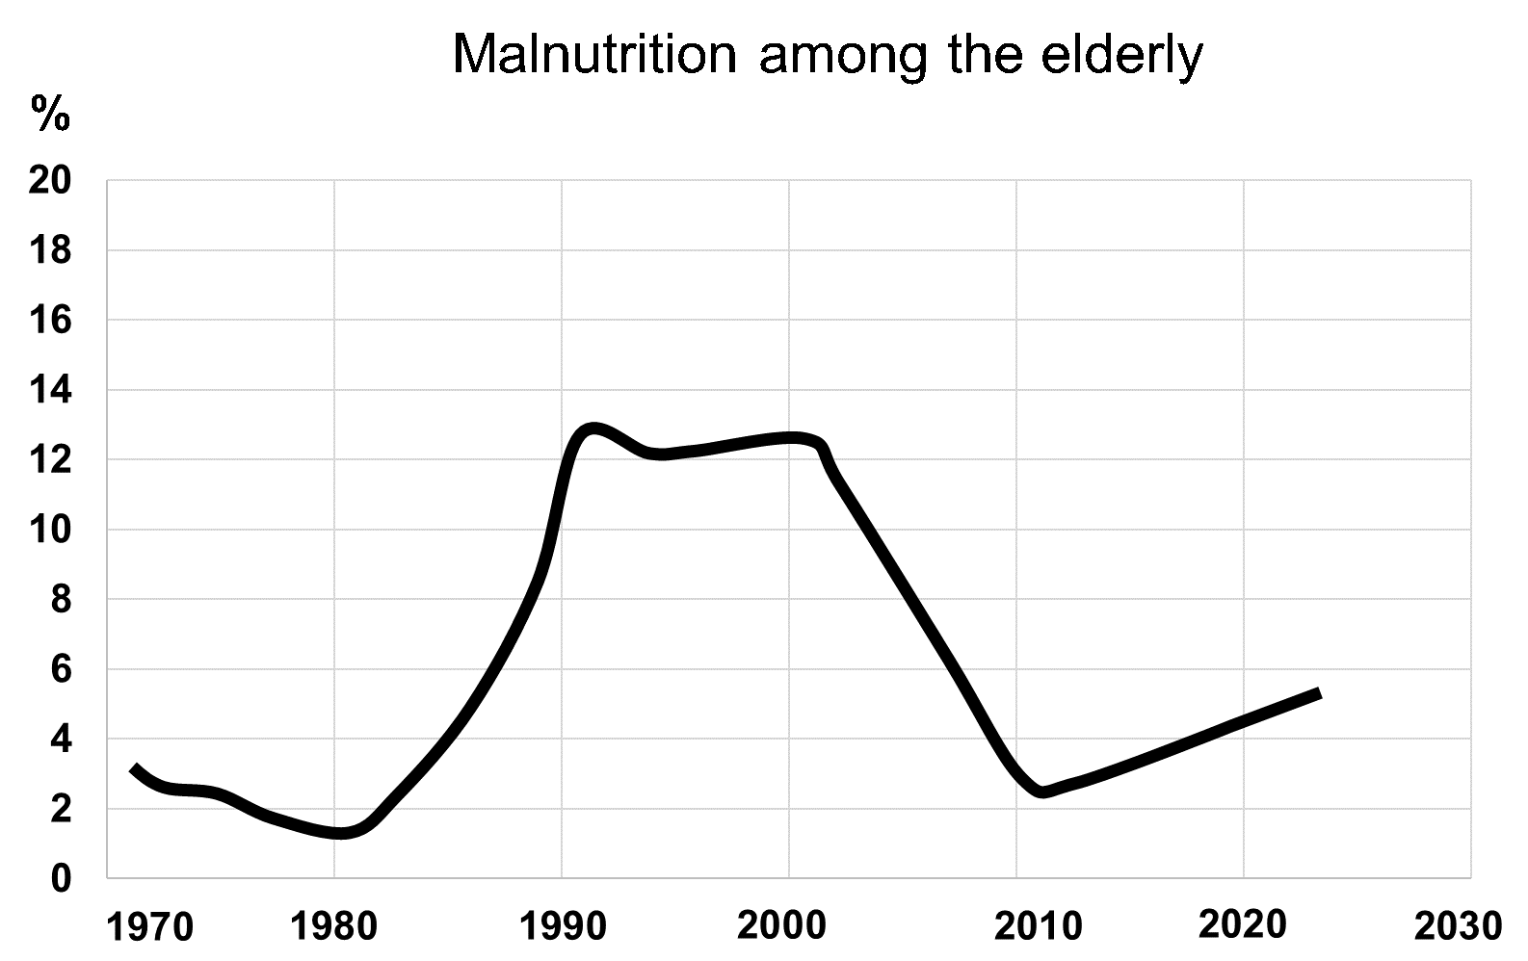
c. Now, let me show you a line graph about the use of dietary supplements by children. I took this graph from a research study done by MIT in 2016. The
1. __________________________________represents the percentages of children using dietary supplements, whereas the 2. _________________________________ represents the months. The percentage of children using supplements was at its
3. __________________________________ level between January and March. Then it
4. __________________________________in March and 5._______________________________ for two months. Supplement use continued to 6.__________________________________ until it reached its 7.__________________________________point in August. Then, it
8. __________________________________ during autumn months and
9. __________________________________ in December. We can conclude that during winter children get sick more often, so they need dietary supplements more to boost their immune system.
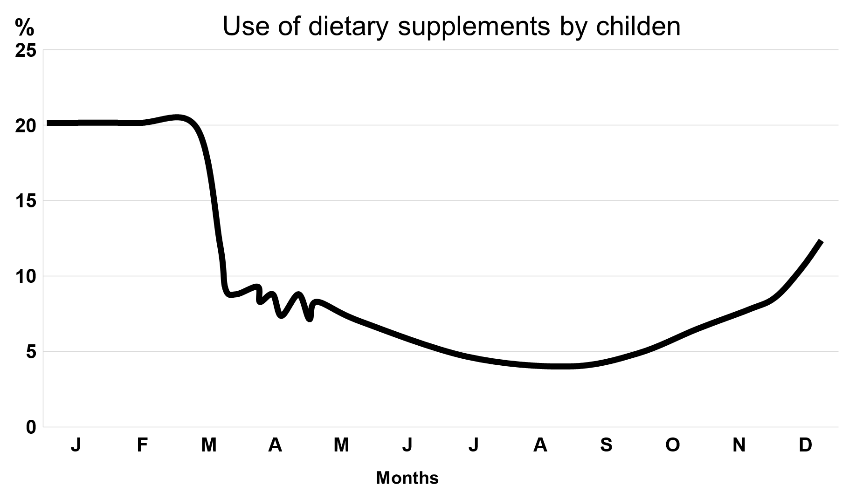

Key:
- 1. line graph
2. horizontal axis
3. vertical axis
4. rose
5. decreased
6. gradual increase
7. peaked
8. fluctuated
9. greater

- 1. c
2. b
3. d
4. a
5. c
6. a
7. b
8. b
9. a

- 1. vertical axis
2. horizontal axis
3. highest
4. fell/dropped sharply
5. fluctuated
6. decrease (continuously)/fall gradually
7. lowest
8. increased gradually
9. rose sharply

